The blind teenager who plays video games by sound (and can beat most of his sighted friends)
- Ben Breen, 19, uses 'muscle memory' to conquer tough games
- Can beat sighted friends at Mortal Kombat games and Rock Band
- Calls for video games to be more accessible for growing community of blind gamers
By Talal Musa
PUBLISHED: 17:17 GMT, 22 January 2013 | UPDATED: 10:48 GMT, 23 January 2013

643 shares

21
View
comments

For most people, the incredibly realistic graphics are the key to enjoying video games.
However, one dedicated player has become a gaming whizz - despite being blind.
Ben Breen, a 19-year-old from Meopham in Kent, was born four months early, and as a result, was left blind from birth.
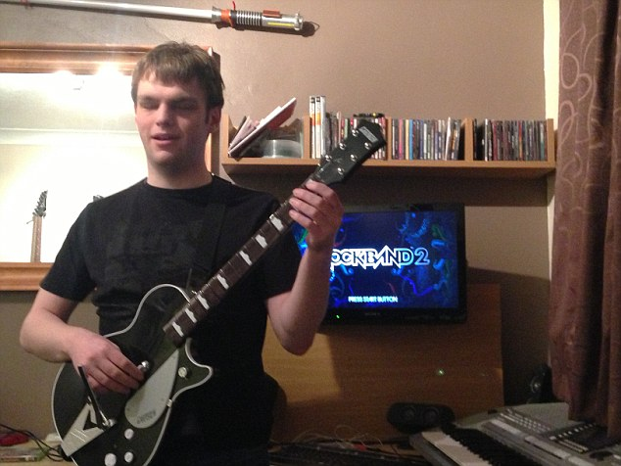
Incredible: Ben has spent hours teaching himself the precise combinations for Rock Band games

HOW HE DOES IT
Where most computer games represent ‘down time’ or a means of relaxation, for Ben, mastering a game requires intense concentration - combining muscle memory with incredibly precise timing to make up for a lack of visual cues.
'In Rock Band (where the player has to press sequences of coloured keys to music) I would sit for around 2 hours at a time, meticulously working on the muscle memory required to play the complex patterns,' he said.
'Eventually, I was able to play some of the hardest songs in the game, including Dream Theatre's Panic Attack.
Despite this, he achieved strong GCSEs from Dartford Grammar school and an international baccalaureate degree.
However, he says it was his introduction to video games that really changed his life.
'At first, I simply enjoyed the sounds of music, and when I discovered I could actually play certain games a few years later, it was amazing,' he said.
'I went for a computer taster day at the Kent Association for the Blind, but whilst others were playing games like Unreal Tournament, I was introduced to a great title called Grizzly Gulch Western Extravaganza.

More...
- The iPad for babies: £85 chewable tablet 'helps one-year-olds develop'
- All the horror with a few new twists - Interview: Aliens: Colonial Marines (Xbox 360 / PS3 / PC / Wii U)
'This was a simple sound-oriented 4-key adventure game aimed specifically at blind gamers, but for the time, it was revolutionary.
'I was so hooked by this Wild West epic that I bought it the next day.
'I began to learn how to use a computer with screen-reading software and from then on I was able to download all the demos I wanted and buy my own games.
I turned to the Wii and tried tennis and realized that if my timing was within a certain window, I could return the ball without any major difficulty.'
Where most computer games represent ‘down time’ or a means of relaxation, for Ben, mastering a game requires intense concentration - combining muscle memory with incredibly-precise timing to make up for a lack of visual cues.
'In Rock Band (where the player has to press sequences of coloured keys to music) I would sit for around 2 hours at a time, meticulously working on the muscle memory required to play the complex patterns. Eventually, I was able to play some of the hardest songs in the game, including Dream Theatre's Panic Attack.
'As for my favourite game, it would probably have to be Mortal Kombat Deception for Playstation 2, and for next-generation consoles, it would probably be Rock Band.’
Although there remains but a handful of games dedicated to the blind or visually impaired player, Ben has not let his condition stop him from enjoying the fruits of the mainstream, and even completing some of the most technically challenging titles around - using his disability to his advantage - especially in the Beat -em-up genre.
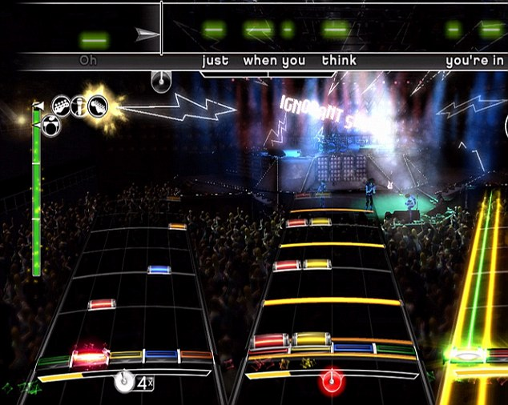
Challenging: Renowned as a difficult game on the hardest settings, Rock Band relies the player to press keys on an 'instrument controller' that correspondent to the visual cues. Ben can play the game and complete the levels without needing to see these cues.
‘I have completed a few story modes, Soulcalibur V and Mortal Kombat 9's to name two. I can also beat my friends consistently at Rock Band, since I’m not distracted by the flashy graphics!’ he jokes.
'I play games with sound alone, which is a lot of fun to show sighted people. I don't let my condition stop me playing a game, and if I have to get sighted friends help to play a 3D game like Duke Nukem ( a first-person shooter), then I will, as I love not only playing competitively, but also blowing things up!
'I urge any gamers who are blind or visually impaired to look into all the equipment options available and see what’s right for them, in terms of situation, price tag and usability.
'I think that blind gamers should try, particularly with music based games, with the normal peripherals and then if they want or need adaptations, alternatives should be available.’
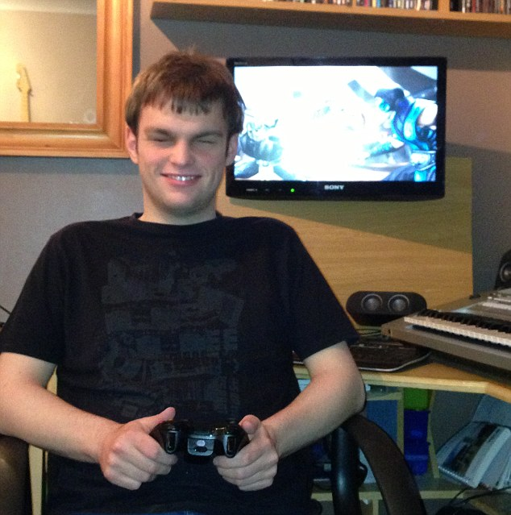
Happy: Gaming has given Ben a new aspect to his life, and he vows to keep searching for games that blind people can play and enjoy.
Unfortunately, inspirational figures are few and far between in the blind gaming community, but Ben points to a couple gamers who gave him the belief that the world of video games wasn't just for sighted to enjoy.
'The blind gamer who inspires me the most is probably a friend of mine by the name of Clement Chou, as he has studied games in so much depth that he knows the mechanics better than most. As for the greatest blind gaming achievement that I am aware of... well...That’s difficult.
'A blind gamer who I have had the fortune to meet in person, by the name of Aaron, has managed to play Lost World Arcade and survive for a lengthy period of time.
'Additionally though, I do know that Yohandi, an American gamer, with no sighted help, has completed the Mortal Kombat Challenge Tower... all 300 missions.’
But for Ben, the industry needs to do more to support the visually impaired community.
He believes the same energy they put into graphical prowess should be put into the development of games taht are accessible and enjoyable for both blind and sighted gamers alike.
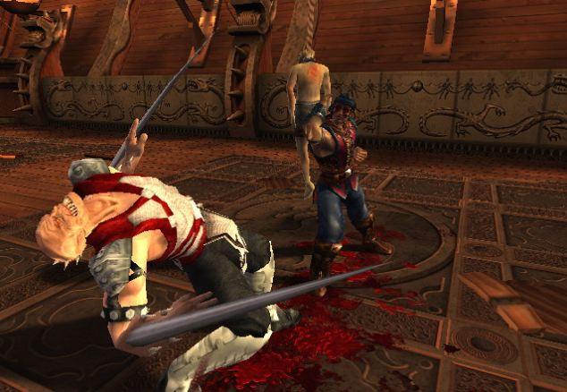
Mortal Kombat-Deception, Ben's favourite game. He says he can beat many of his sighted friends simply by recognising the sounds characters and moves in the game produce

WHAT IS MUSCLE MEMORY?
Muscle memory is a type of memory that is 'taught' through repetition - such as riding a bicycle, typing and playing a musical instrument.
When a movement is repeated over time, a long-term muscle memory is created for that task, eventually allowing it to be performed without conscious effort.
This process decreases the need for attention and creates maximum efficiency within the motor and memory systems.
'The gaming industry needs to support more visually impaired gamers, definitely. We aren't getting much help from other communities as well - certain gaming sites just don't seem to appreciate that blind people can play games.
'Also, the developers aren't making things like high-contrast colours a priority.
'A universal way for developers to help us is possibly have an accessibility mode implemented, whereby things like locking tones in shooters, or stereo panning in racing games to show where your car is are added.
'However, these would be designed to make the game no easier than it is for anyone else. Also, spoken tutorials would be extremely useful for sighted and blind players alike, since if executed correctly they are invaluable in improving strategy, ability or general understanding.’
There is, however, one piece of hardware that Ben would like to see created in the coming years. ‘It is simply a glove, or rather a pair,' he explains.
‘When the gloves are recognised by the Xbox 360 Kinect, if the players' hand is over an option, a small sensor in the palm will vibrate to tell them so.
'Then the option would be spoken by a synthesizer built into the firmware of the Xbox.
'This technology could then be adapted into light guns.
'It would be great as a tool for navigating without the controller.'
At the moment, the thought of such a device is nothing more than a dream. But given how far technology has advanced, it is only a matter of time before developers listen to the blind community and make this a reality.
For now at least, the wait gives Ben all the more time to practice. And to continue beating his sighted friends at their own game.
Follow us on Twitter: @DailyMailGames and on Facebook: Daily Mail Games.
Read more: http://www.dailymail.co.uk/sciencetech/article-2266516/Meet-blind-teenager-Ben-Breen-cracked-video-game-world-relying-solely-sound.html#ixzz2h4GNcCMs
Follow us: @MailOnline on Twitter | DailyMail on Facebook

