The Best Accessible Computer Games for Blind Kids
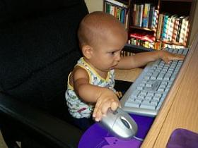
- up
509
Votes
share this
- Facebook
- Twitter
- Forward

Kids are kids, whether they are blind or multiply disabled or not. And most kids these days want to play video games!
You may have thought that your child can't play computer or video games because he's blind or that he won't be interested in those sort of things.
You may be surprised to learn that there is an entire industry devoted to producing fun and educational computer games for blind and visually impaired children!
Check out our list of accessible video games and see if you can find something that your child will enjoy!

Computer Games for Blind Toddlers and Younger Kids
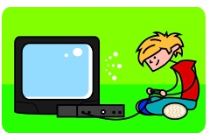
- 7-128: This company specializes in educational video games for blind and visually impaired children. Their software works with both Windows and Macs. Check out their PizzaGames for blind toddlers!
- Inclusive Technology: Inclusive Tech makes switches and touch screen software designed to help kids with communication problems. Our son loves the games where he needs to press his switch to get the story or song to continue. These games aren't specifically designed for blind children, but most are easily adapted.
- Priory Woods: This resource page provides tons of free downloadable games that are switch or touch-screen accessible. Like Inclusive Tech, these games aren't designed specifically for blind kids, but they are so simple that they adapt easily.

Computer Games for Blind Teens and Adults

- Bavisoft: This company designs adventure video games for older kids and adults. Their games are produced for blind and visually impaired players and I've heard that they are addictingly entertaining. Check out Grizzly Gulch or Chillingham.
- AudioGames.net: This site provides a list of video games on the internet that are either entirely sound based or designed for blind players. Some of these games are free and some require subscriptions, but the list of games is so long you're sure to find something that fits your needs.
- VI Fit: VI Fit creates video games that can be played with a Wii Remote. You provide the controller (which you can get for about $20) and they provide the games! All of their games are free and designed to get your child up and moving. And of course they are all easy to play with no vision.
- Azabat: Azabat creates audio-based games for blind players that are easy to use and easy to install. These games are not downloaded and don't require the use of a screen reader, just pop in a CD and you're ready to play!
- PCS Games: Another long list of downloadable games on the internet for blind or visually impaired players. They include games for Windows or Mac as well as forums and gaming news.
- Kitchens Inc.: This site develops free audio games for Windows computers. You'll find everything from racing and arcade games to word and puzzle games.
- GMA Games: This company produces some of the most popular video games for blind players, like Shades of Doom, the Star Trek game Trek 2000, and PacMan Talks.
- Top 25 Sites for Gamers who are Blind: If you're still looking for more information about computer games for blind players, check out this article from 7-128. They list their favorite twenty-five sites. Find forums, developer info, and lots and lots of games!

